**Difference**

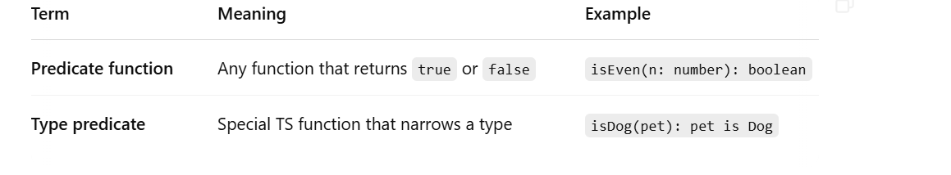

**Challenge: Create a predicate function to check if a pet is a Cat**

You have the following setup:

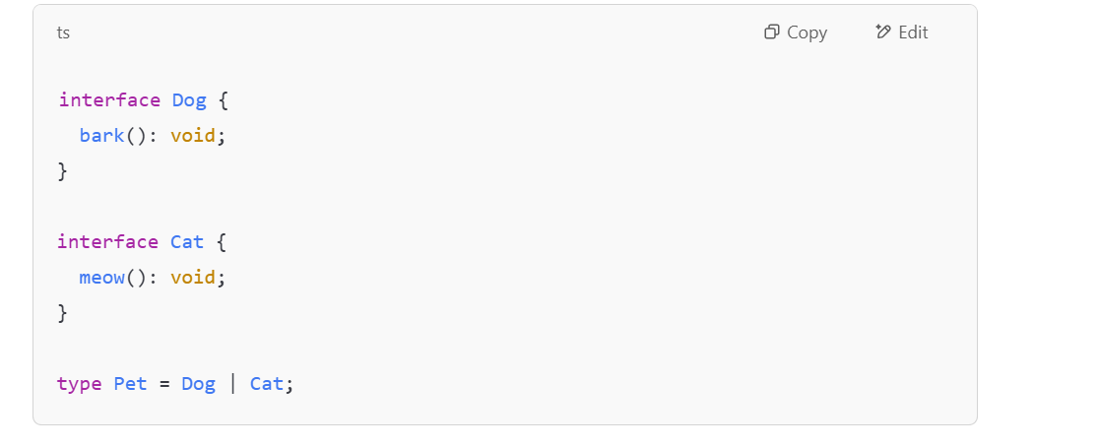**✅ Your Task:**

1. Write a function called isCat that returns true if the pet is a Cat.
2. Use it in a describePet(pet: Pet) function to log "It’s a Cat" or "It’s a Dog".

